**Introduction**

Among all types of corruption, police corruption is arguably the one that most directly hurts society, as those trusted with protecting people either side with the criminals, or are themselves, criminals.

However, corruption is difficult to measure quantitatively other than by perception surveys, but the perception that citizens have of this phenomenon may differ from reality.

When society considers most police officers to be corrupt, police corporations lose legitimacy to enforce the law. This is the case in Mexico, where 74% of citizens consider all police corporations to be corrupt.

A harmful consequence of an inflated perception of corruption is that it may enhance corrupt behavior, as has been corroborated by the Labeling Theory of Criminology.

This theory states that labeling someone a criminal makes that person more prone to commit criminal acts. So what motivation do officers have to be honest and protect a society that disrespects and criminalizes them because of an excessive perception of corruption levels?

In this paper, the authors analyze *how crime levels change as a function of police corruption and its perception*.

**Methodology**

This paper utilizes an agent-based model to explore the dynamics between police corruption, public perception of corruption, and crime rates in Mexico. An agent-based model is a computational model that simulates the interactions of individual agents (in this case, police officers, criminals, and regular citizens) to assess their effects on the system as a whole.

This approach allows the study to examine complex systems and emergent behaviors that arise from the rules governing individual actions and interactions.

**Methodology #2**

The simulation runs over time to observe how crime spreads across the population under different conditions.

The findings are based on simulations that produce a variety of outcomes under different scenarios, showing how changes in police corruption and public perception can significantly impact crime incidence.

This methodology offers a valuable tool for policymakers to improve public safety in Mexico and other contexts with similar challenges.

Police officers can be either honest or corrupt. Honest officers will never accept a bribe, while corrupt ones always accept bribes above their corruption threshold.

The model incorporates several key parameters, such as the probability of a regular citizen becoming a criminal, the effect of capturing crime lords, and the impact of seizing crime-related assets.

**Main Findings #1**

This graph shows the relationship between the crime incidence rate (the y axis) and the fraction of honest police officers (the x axis). As we move to the right, the number of honest officers increases. Different colors indicate different levels of the “maximum turning probability” (Pm), which is a measure of how likely an honest officer is to turn corrupt.

This graph tells us how the amount of crime changes as we have more honest officers. When there's no inflated perception of corruption (the solid lines), crime decreases as the number of honest officers increases. However, if people believe there's more corruption than there actually is (which are the dashed lines), having more honest officers doesn't reduce crime as much as it should.

**Main Findings #4**

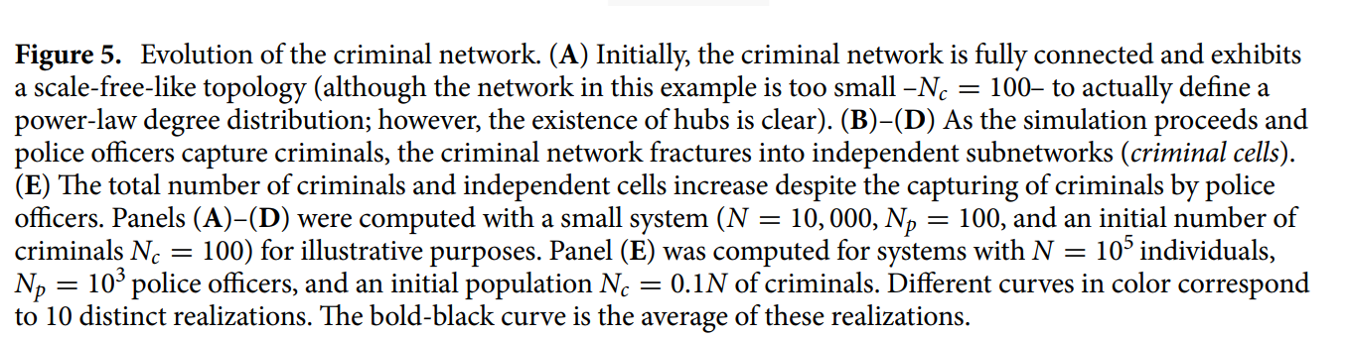

**Relation to the Course**

* Its relation to the course stems from its use of network analysis to determine how society deems police corruption and correlates it to the seemingly increased crime rates due to the public's perception of them, even though the findings disprove that and shows that the correlation is in fact false.
* The models involve the construction and evolution of criminal networks, where criminals are organized in hierarchical structures. This aspect of the model allows for the analysis of network properties such as connectivity, centrality, and modularity. It also employs a preferential attachment algorithm based on money to simulate the formation of connections in the criminal network. This algorithmic approach is fundamental in understanding the emergence of network hubs and the distribution of node degrees, which was well covered in the course.
* Data mining techniques are applied to analyze patterns in simulated crime data and identify factors contributing to crime outbreaks. By analyzing large-scale datasets generated by the simulation, the paper identifies correlations and dependencies among variables related to corruption as such.

**Strengths**

While the study focuses on Mexico, the methodology and findings have broader applicability. The model can be adapted to other countries or regions facing similar issues of police corruption and organized crime, making it a valuable tool for comparative studies and international policy development.

Corruption and its perception are challenging to measure directly. This study quantitatively models these aspects, offering a novel approach to understanding the impact of police corruption and public perception on crime rates, bridging a gap between qualitative observations and quantitative analysis

The use of an agent-based model is a significant strength, offering a sophisticated and flexible approach to simulate complex social dynamics. This methodology allows for the examination of individual behaviors and their aggregate effects on the system, providing insights that are not easily obtainable through traditional statistical methods

**Limitations**

The model does not simulate potential conflicts between different criminal groups or cells after a large criminal organization is fractured. These conflicts can impact the dynamics of crime and violence, altering the landscape of organized crime in ways not captured by the current model.

The simulations do not account for the efforts of law enforcement to combat corruption within its ranks, such as initiatives to cease or arrest corrupt officers. This limitation means the model might not accurately reflect the potential impact of internal anti-corruption measures on reducing overall levels of corruption and its influence on crime rates.

The study does not incorporate a feedback mechanism between the public's perception of police corruption and the actual fraction of corrupt police officers. This oversight means the model may not fully capture the cyclical nature of corruption, where increased perception of corruption could lead to higher actual levels of corruption within the police force, as suggested by the Labelling Theory